William Dixon 9/29/2020
CIS4041
Unit 4 Lab 2.10

Created error in Design2.html, checked file and received the following errors:
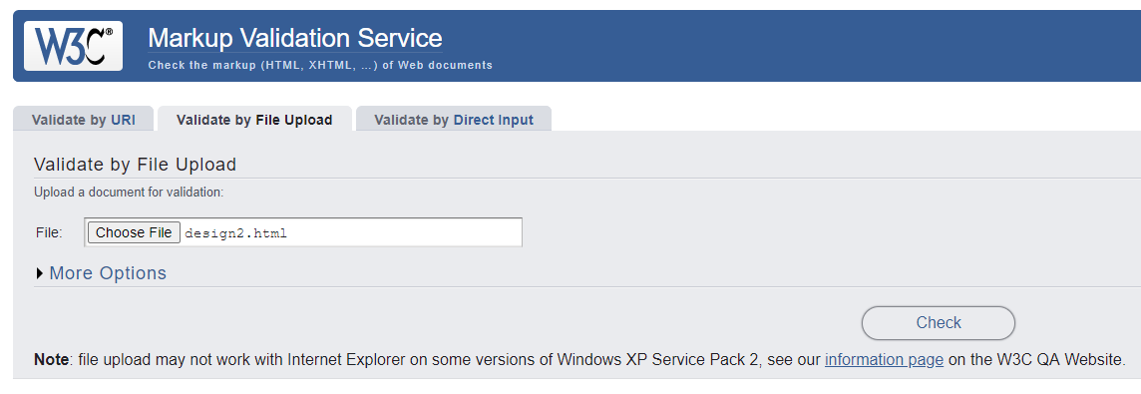
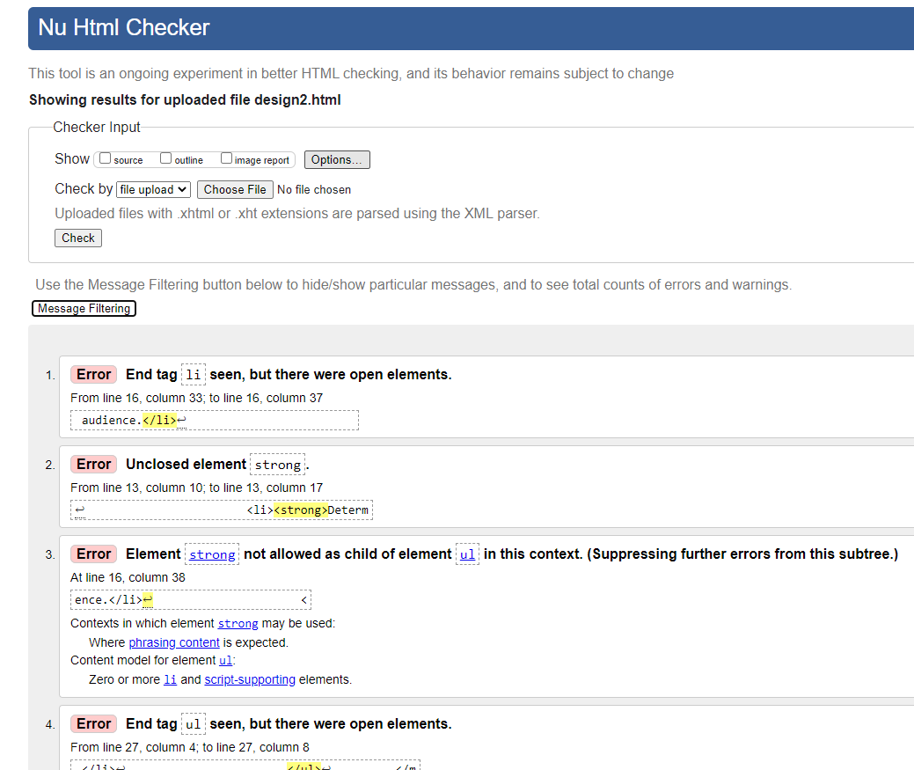
After fixing error ran test again:
